| Cybersecurity |
| --- |
| Project 1 Technical Brief |

Make a copy of this document before you begin. Place your answers below   
each question. This completed document will be your deliverable for Project 1. Submit it through Canvas when you’re finished with the project at the end of the week.

## Your Web Application

Enter the URL for the web application that you created:

| https://cwsecblog.azurewebsites.net/ |
| --- |

Paste screenshots of your website created (Be sure to include your blog posts):

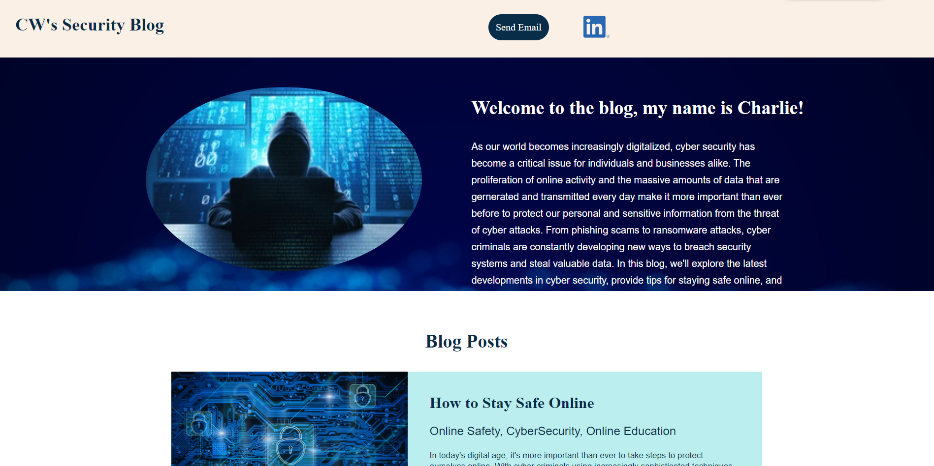

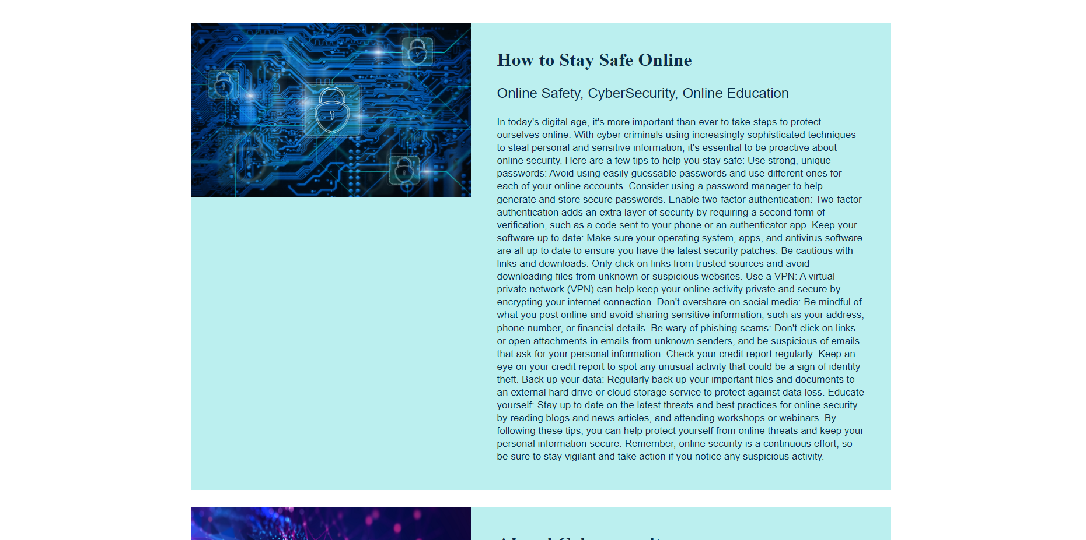

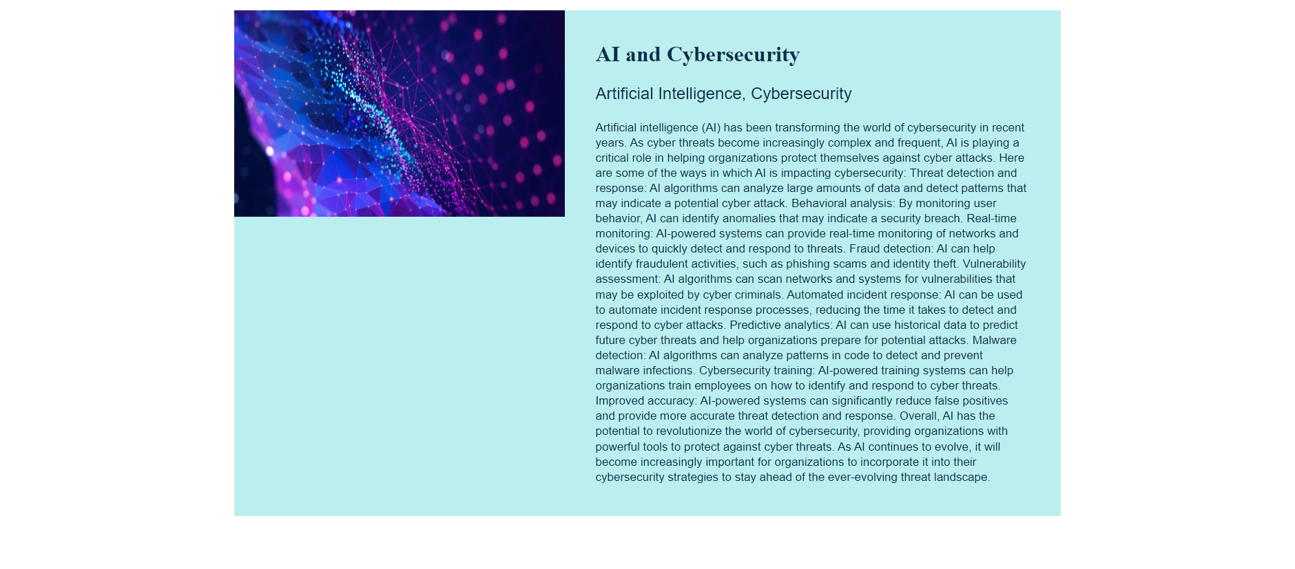

## Day 1 Questions

### General Questions

1. What option did you select for your domain (Azure free domain, GoDaddy domain)?

| Azure |
| --- |

1. What is your domain name?

| cwsecblog.azurewebsites.net |
| --- |

### Networking Questions

1. What is the IP address of your webpage?

| 20.119.8.30 |
| --- |

1. What is the location (city, state, country) of your IP address?

| Tappahannock, Virginia, United States |
| --- |

1. Run a DNS lookup on your website. What does the NS record show?

| ns1-05.azure-dns.com internet address = 40.90.4.5  Ns2-05.azure-dns.net internet address = 64.4.48.5  Ns3-05.azure-dns.org internet address = 13.107.24.5  Ns4-05.azure-dns.info internet address = 13.107.160.5 |
| --- |

### Web Development Questions

1. When creating your web app, you selected a runtime stack. What was it? Does it work on the front end or the back end?

| PHP 8.0, Back end. |
| --- |

1. Inside the /var/www/html directory, there was another directory called assets. Explain what was inside that directory.

| Utilities and photos used to create the blog website. |
| --- |

1. Consider your response to the above question. Does this work with the front end or back end?

| Front end |
| --- |

## Day 2 Questions

### Cloud Questions

1. What is a cloud tenant?

| Either a single user or a group of users that use the services provided by a cloud service provider. |
| --- |

1. Why would an access policy be important on a key vault?

| Protecting sensitive information, complying with regulatory requirements, monitor and manage access. |
| --- |

1. Within the key vault, what are the differences between keys, secrets, and certificates?

| Keys are used for cryptography purposes, secrets are utilized to protect sensitive information, and certificates are used to verify the identity of entities. |
| --- |

### Cryptography Questions

1. What are the advantages of a self-signed certificate?

| Cost-effective, quick to setup, great for internal use, and offers a level of encryption. |
| --- |

1. What are the disadvantages of a self-signed certificate?

| Lack of trust, no validation of identity, not ideal for public-facing websites. |
| --- |

1. What is a wildcard certificate?

| It allows a single certificate to secure multiple subdomains of a domain. |
| --- |

1. When binding a certificate to your website, Azure only provides TLS versions 1.0, 1.1, and 1.2. Explain why SSL 3.0 isn’t provided.

| SSL 3.0 is an older version that has since been superseded by TLS protocols which are more secure. |
| --- |

1. After completing the Day 2 activities, view your SSL certificate and answer the following questions:
   1. Is your browser returning an error for your SSL certificate? Why or why not?

| No, I’m using Azure’s free domain which already provides a certificate. |
| --- |

* 1. What is the validity of your certificate (date range)?

| 3/29/2023-3/28/2024 |
| --- |

* 1. Do you have an intermediate certificate? If so, what is it?

| Yes, Microsoft Azure TLS Issuing CA 05 |
| --- |

* 1. Do you have a root certificate? If so, what is it?

| Yes, DigiCert Global Root G2 |
| --- |

* 1. Does your browser have the root certificate in its root store?

| Yes |
| --- |

* 1. List one other root CA in your browser’s root store.

| GlobalSign Root CA |
| --- |

## Day 3 Questions

### Cloud Security Questions

1. What are the similarities and differences between Azure Web Application Gateway and Azure Front Door?

| Both reside in front of your web app to project it. The primary solution for both is a load balancer. The Web Application Gateway is more regional and best suited for a web app in a single region, while the Azure Front Door is more global and better suited for web apps in a variety of regions. |
| --- |

1. A feature of the Web Application Gateway and Front Door is “SSL Offloading.” What is SSL offloading? What are its benefits?

| The process of decrypting SSL/TLS encrypted traffic at a certain point in a network architecture and then forwarding the traffic to its destination in the unencrypted form. Benefits include, improved server performance, reduced latency, scalability, security and ease of management. |
| --- |

1. What OSI layer does a WAF work on?

| Layer 7, Application Layer |
| --- |

1. Select one of the WAF managed rules (e.g., directory traversal, SQL injection, etc.), and define it.

| SQL Injection Attack:Common Injection Testing Detected-indicates the WAF has detected a common pattern used in SQL Injection Testing, which is often used by attackers probing for vulnerabilities. |
| --- |

1. Consider the rule that you selected. Could your website (as it is currently designed) be impacted by this vulnerability if Front Door wasn’t enabled? Why or why not?

| Yes without Front Door, the web app would be vulnerable to many attacks including the SQL Injection Testing. Front Door provides additional security but also doesn’t guarantee complete protection from attacks. |
| --- |

1. Hypothetically, say that you create a custom WAF rule to block all traffic from Canada. Does that mean that anyone who resides in Canada would not be able to access your website? Why or why not?

| No it does mean that any Canadian IP addresses would not be able to access the site but that doesn’t prevent someone in Canada from using a VPN to utilize a non-Canadian IP address to access the web app. |
| --- |

1. Include screenshots below to demonstrate that your web app has the following:
   1. Azure Front Door enabled

|  |
| --- |

* 1. A WAF custom rule

|  |
| --- |

## Disclaimer on Future Charges

Please type “**YES**” after one of the following options:

* ***Maintaining website after project conclusion****: I am aware that I am responsible for any charges that I incur by maintaining my website. I have reviewed the* [*guidance*](https://docs.google.com/document/d/1ZzC4oTJFdlkkeWuzuJAyVSqtDFbuAWilmwXg8PZgzMs/edit) *for minimizing costs and monitoring Azure charges.*
* ***Disabling website after project conclusion****: I am aware that I am responsible for deleting all of my project resources as soon as I have gathered all of my web application screen shots and completed this document. YES*

© 2022 Trilogy Education Services, a 2U, Inc. brand. All Rights Reserved.